
CS 255 System Design Document Template

Alexis Prazak
CS255 Systems Design and Analysis
12/16/2023

UML Diagrams

UML Use Case Diagram
Below is the use case Diagram for DriverPass. It captures the functions customers and employees have access to.
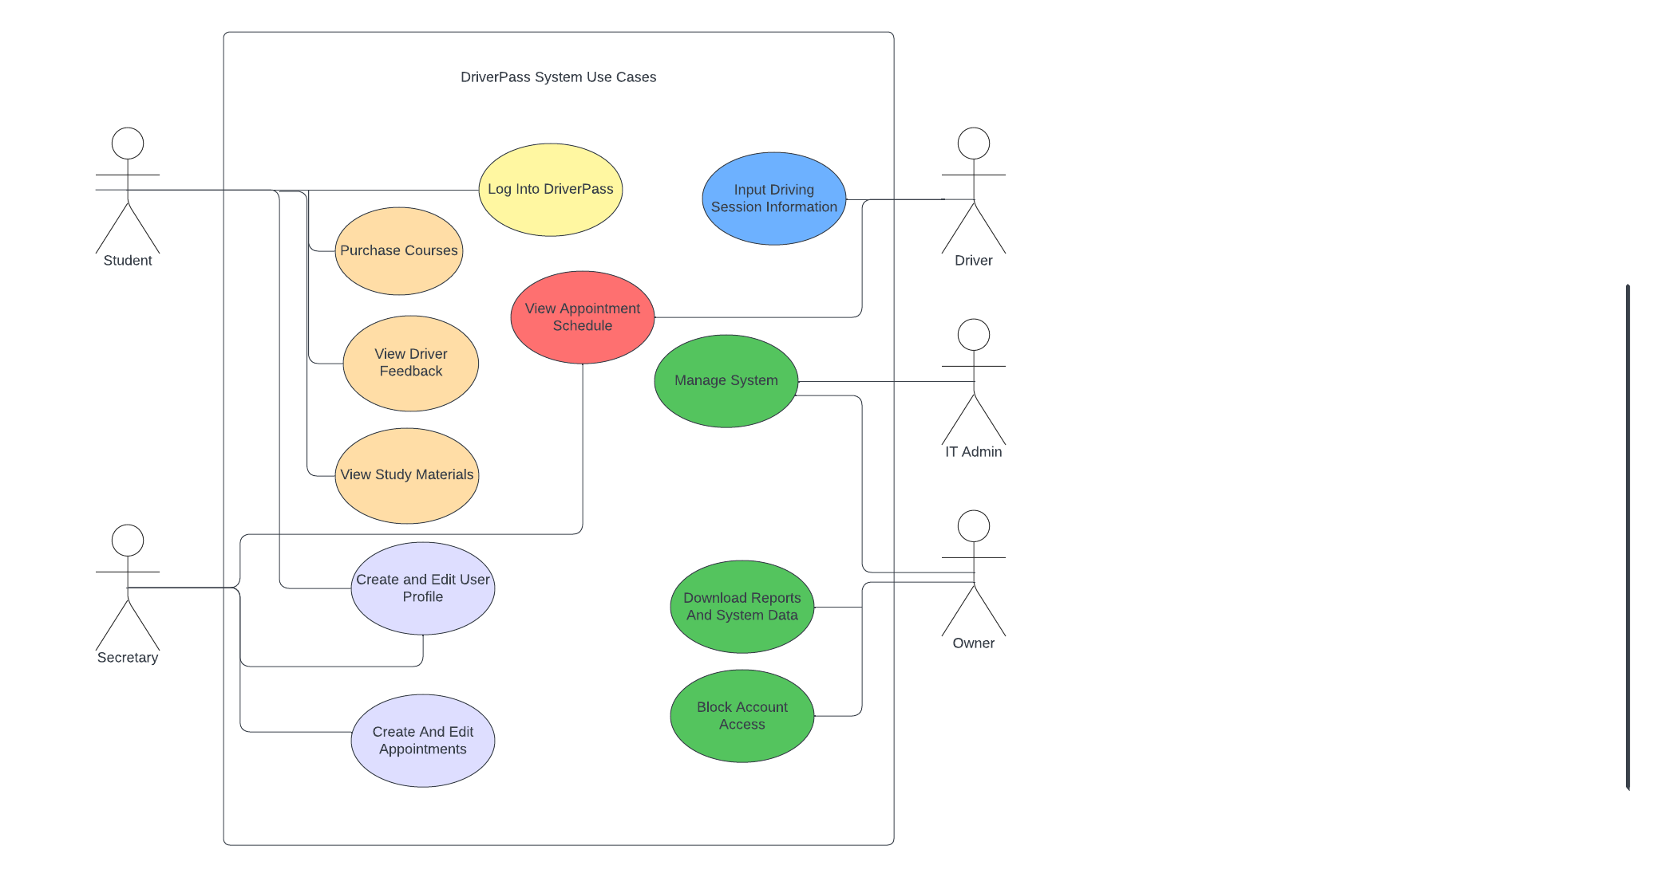

UML Activity Diagrams
The first UML Activity diagram follows the steps users will take to reset their password. This is a key component for the system's security.
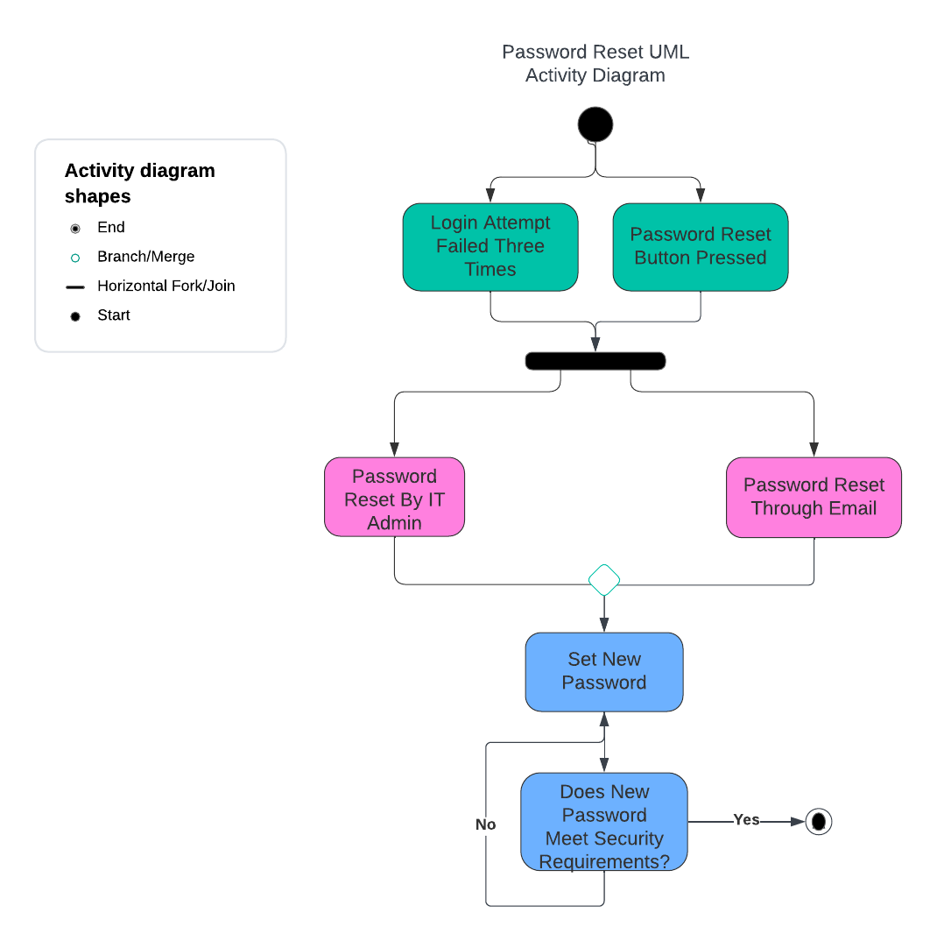
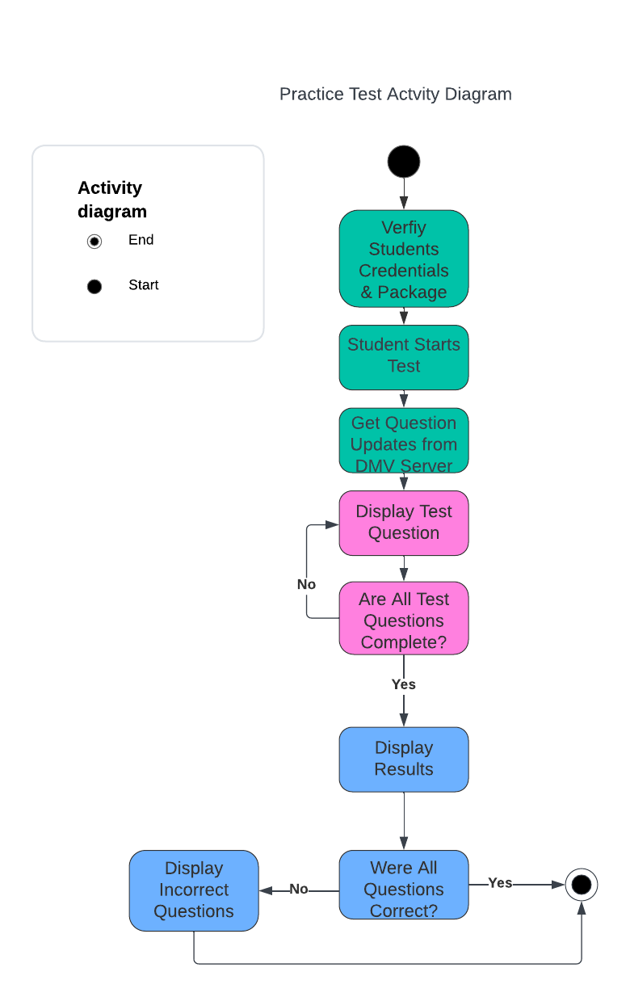
The second UML Activity diagram shows the steps for a student completing a practice test. Special attention is paid the sequence of events to ensure the system gets updated DMV materials before the test begins.

UML Sequence Diagram
This UML Sequence diagram details the process a user goes through when making an appointment. There are two paths depending on whether a user has purchased a package or not.
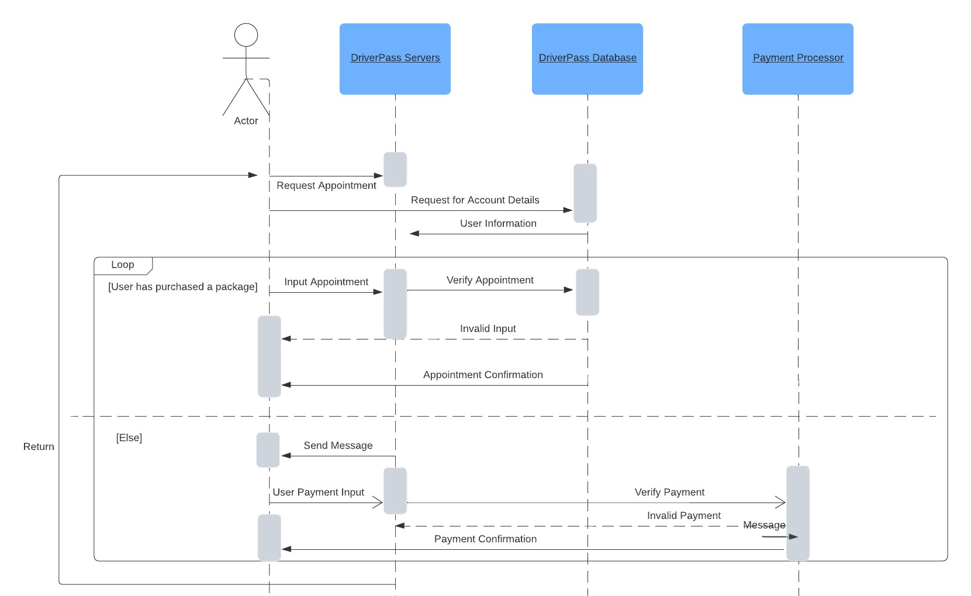

UML Class Diagram

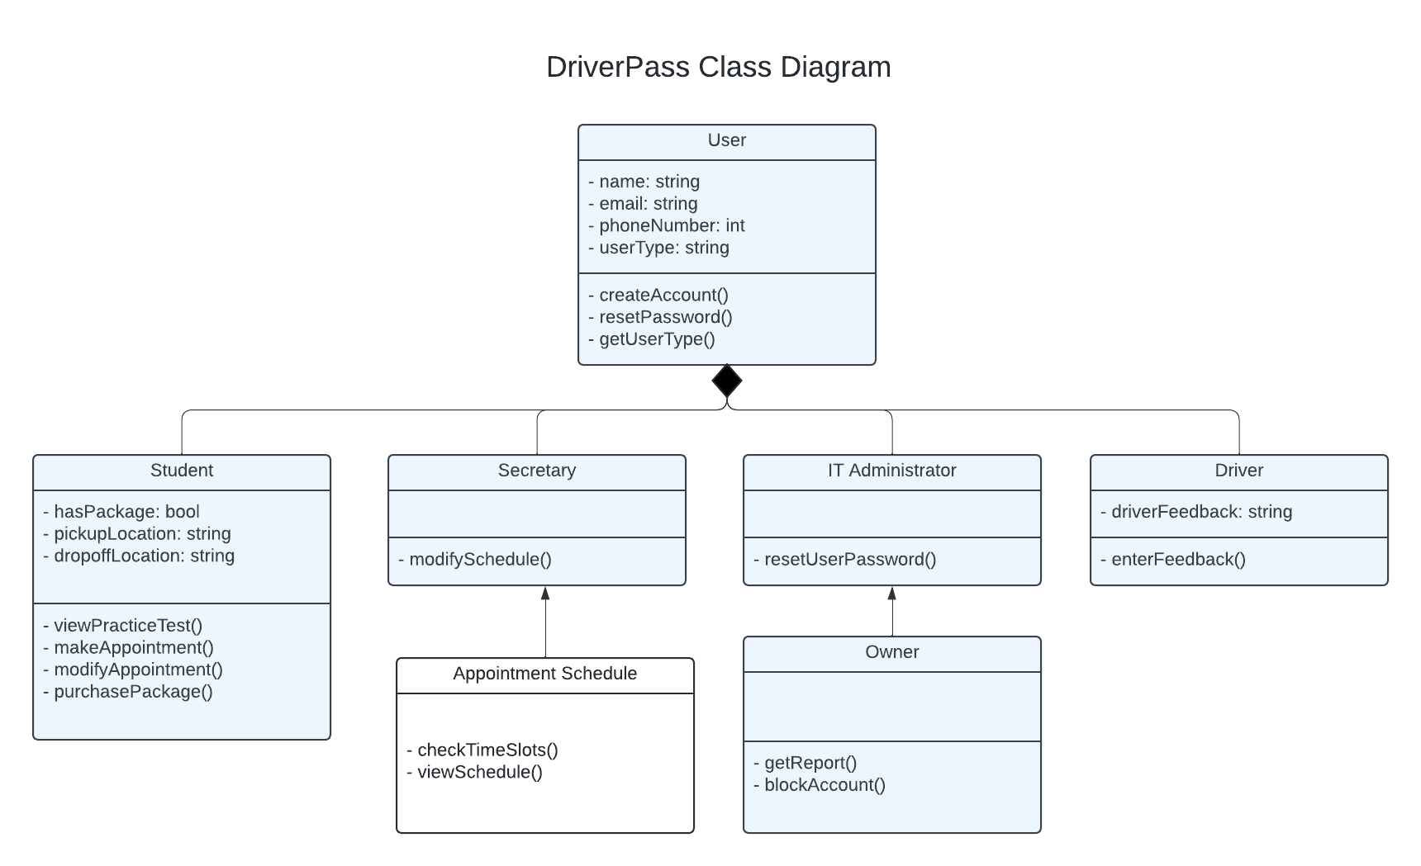

Technical Requirements

- The system will need a cloud based storage system.
- The system shall have a responsive user interface.
- The system will send data over an encrypted connection.
- The system should connect to the DMV's system to ensure accurate information to students.
- The system will be able to track user activity that can be saved in a downloadable report. This can be done in a CSV or PDF file.
- The system will need to be connected to the internet 24/7.
- Users will need a desktop or mobile device to access the system.
- The system shall require unique login credentials for each user.

